**Assignment 10**

**Q1. Pascal's Triangle**

**Code:**

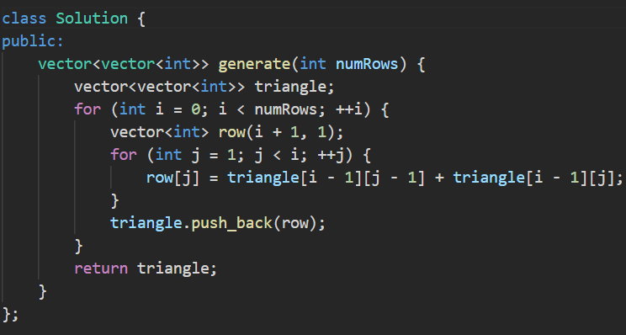

**Output:**

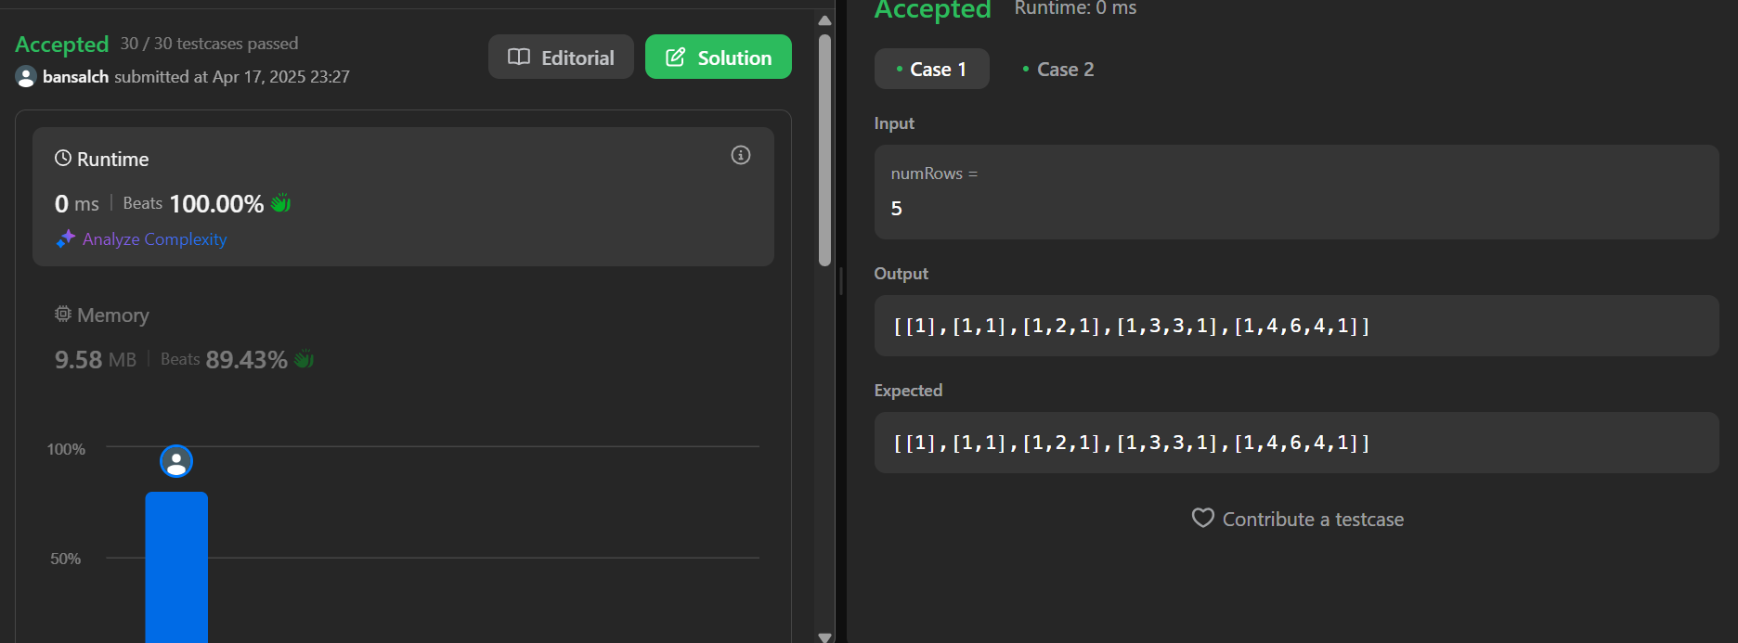

**Q2. Hamming Distance**

**Code:**

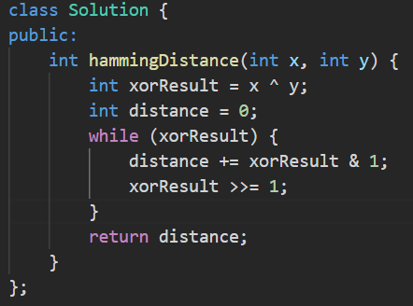

**Output:**

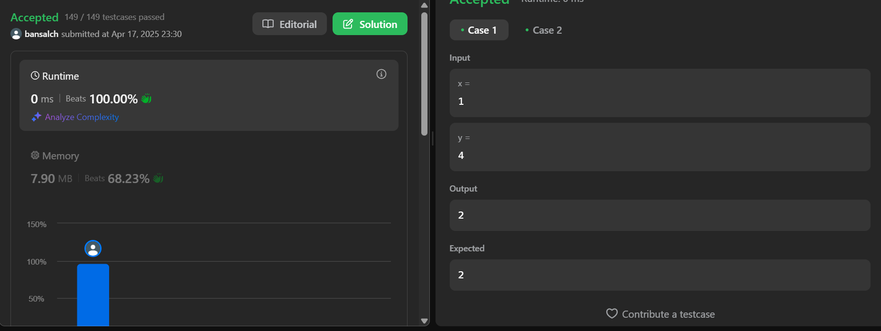

**Q3. Task Scheduler**

**Code:**

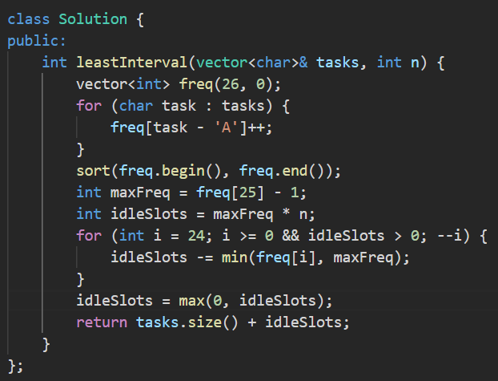

**Output:**

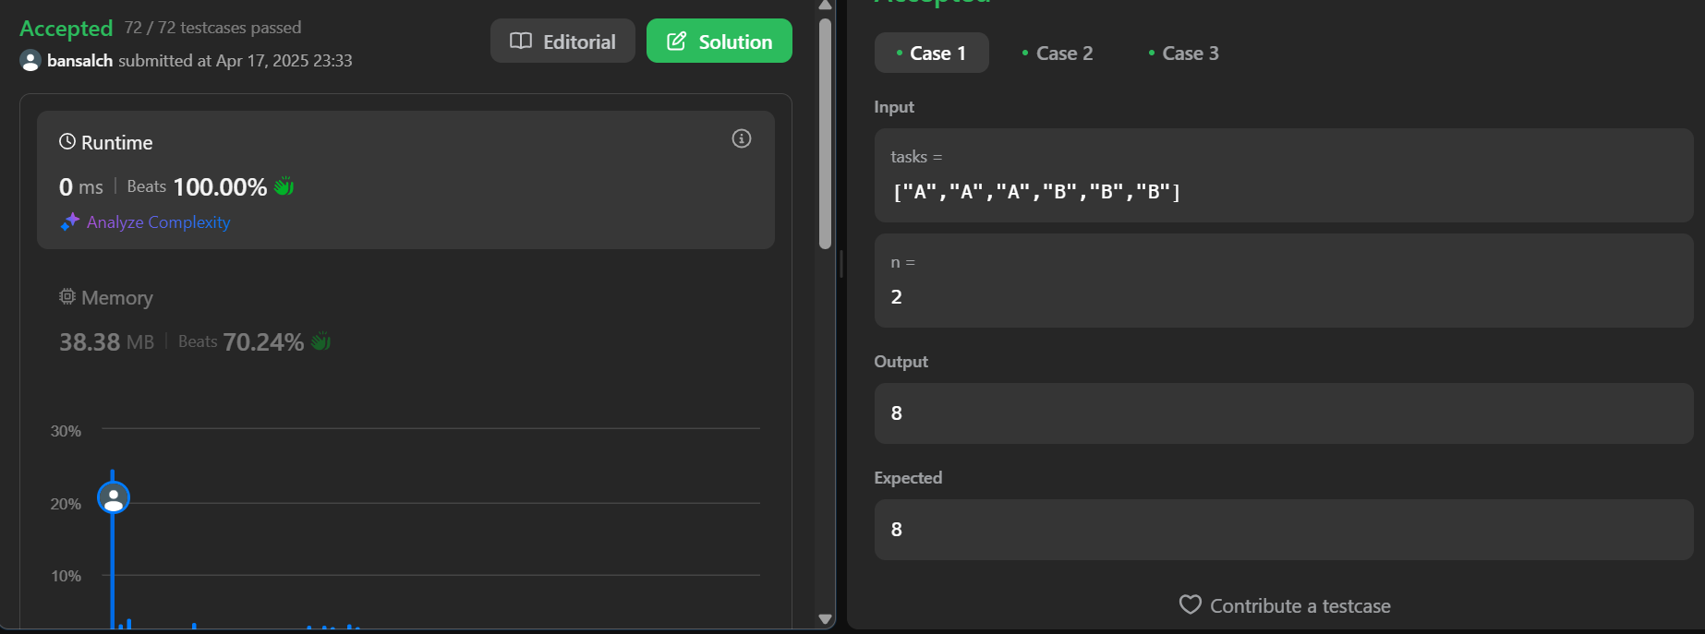

**Q4. Number of 1 Bits**

**Code:**

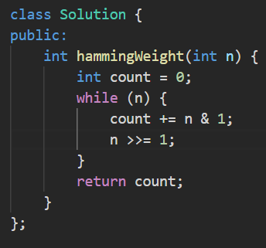

**Output:**

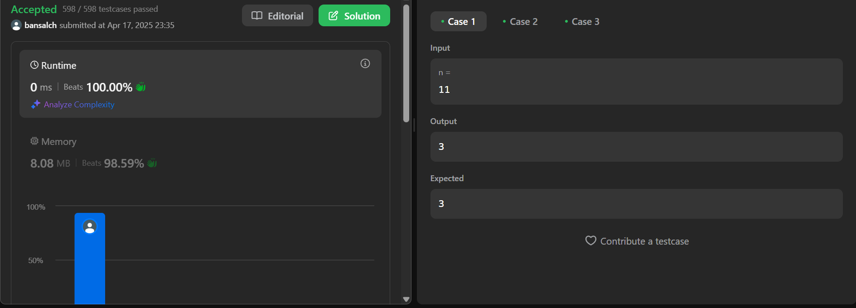

**Q5. Divide Two Integers**

**Code:**

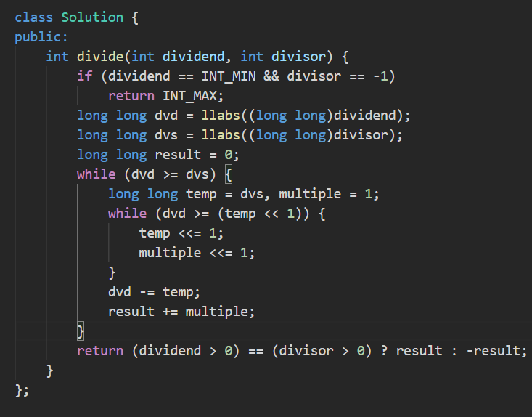

**Output:**

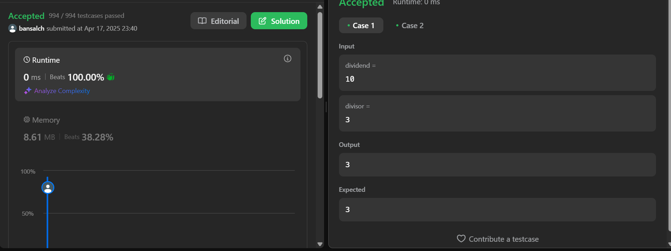

**Q6. Trapping Rain Water**

**Code:**

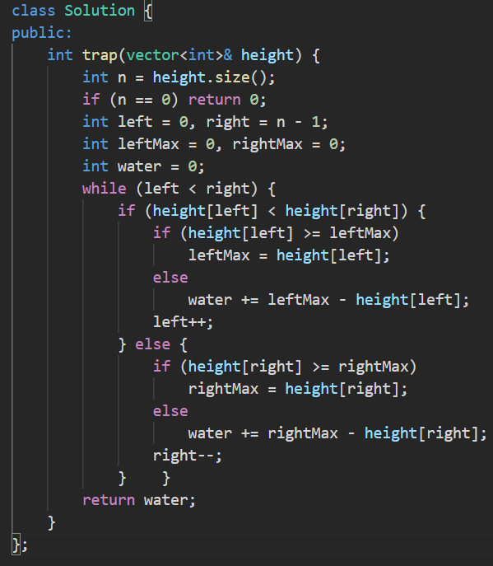

**Output:**

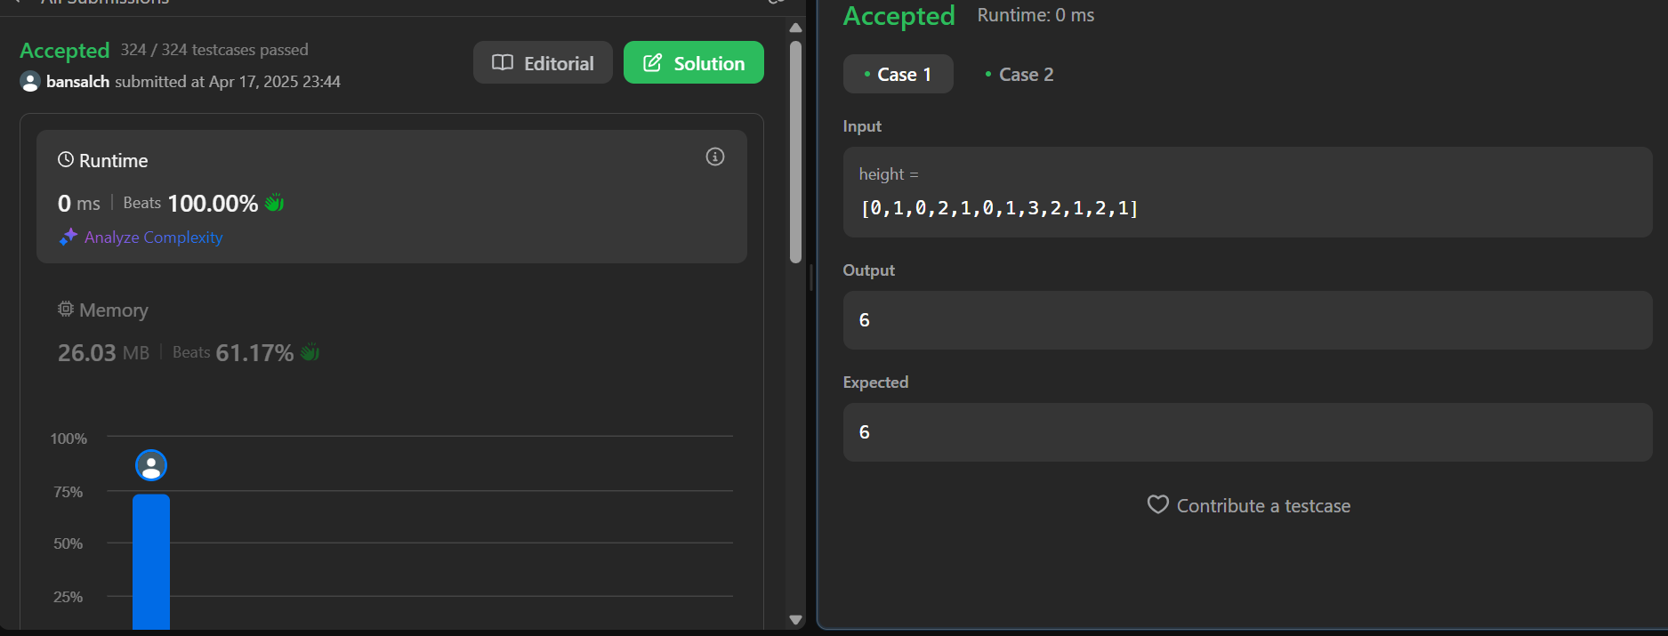

**Q7. Max Number of Tasks You Can Assign**

**Code:**

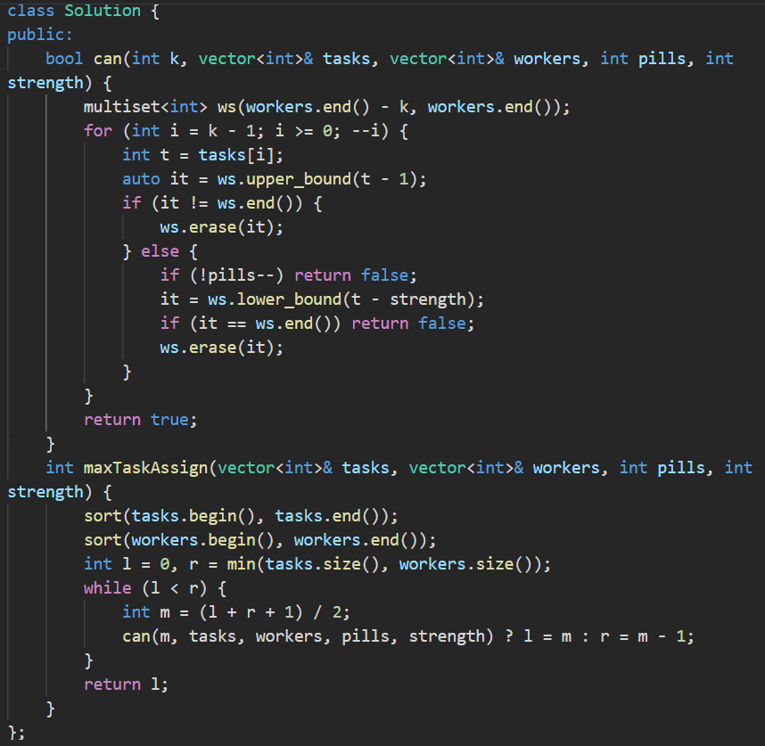

**Output:**

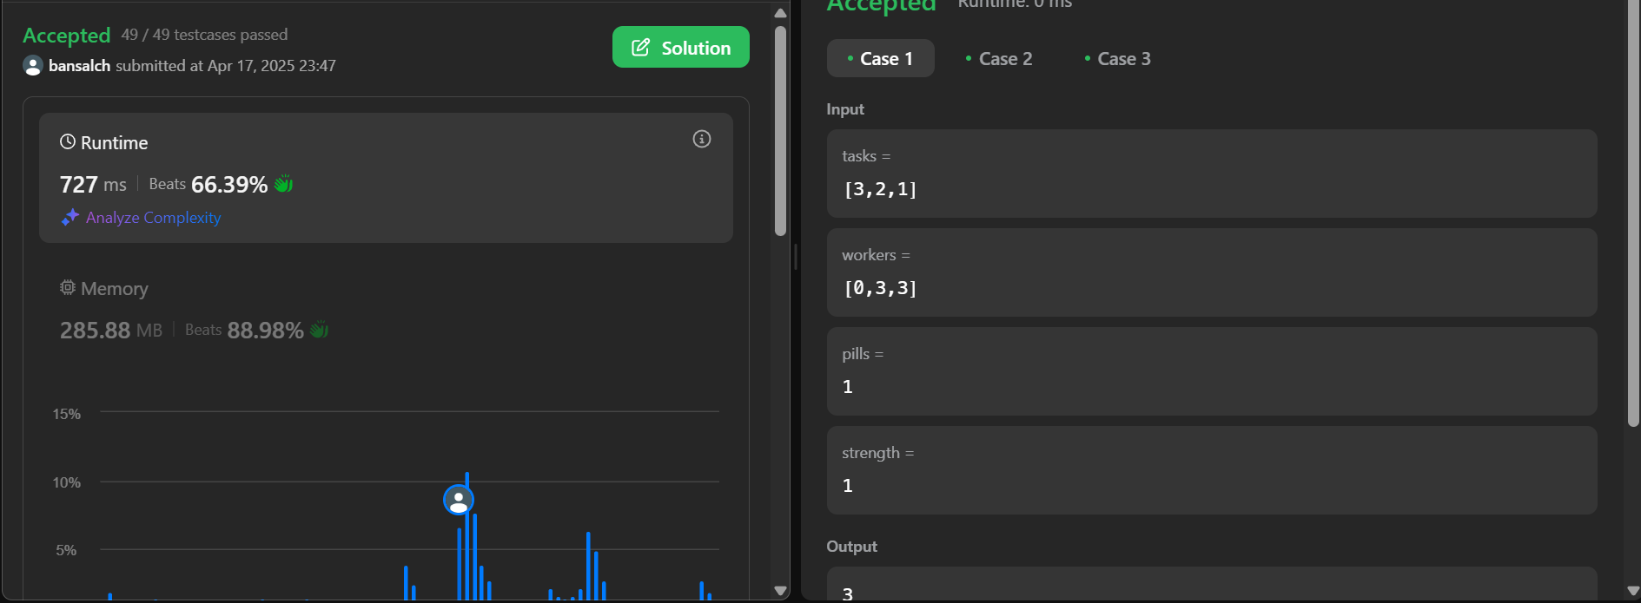

**Q8.** **Serialize and Deserialize Binary Tree**

**Code:**

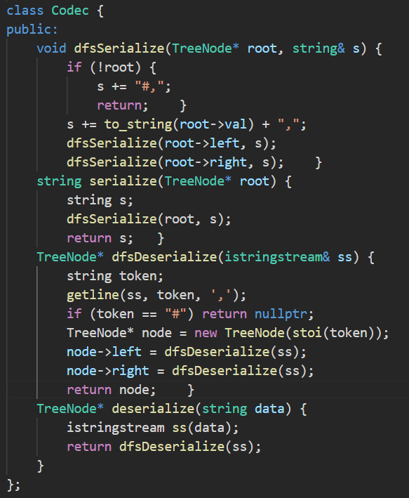

**Output:**

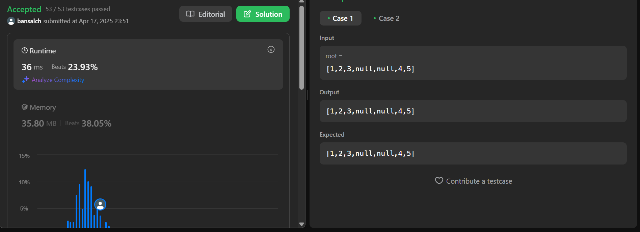

**Q9. LRU Cache**

**Code:**

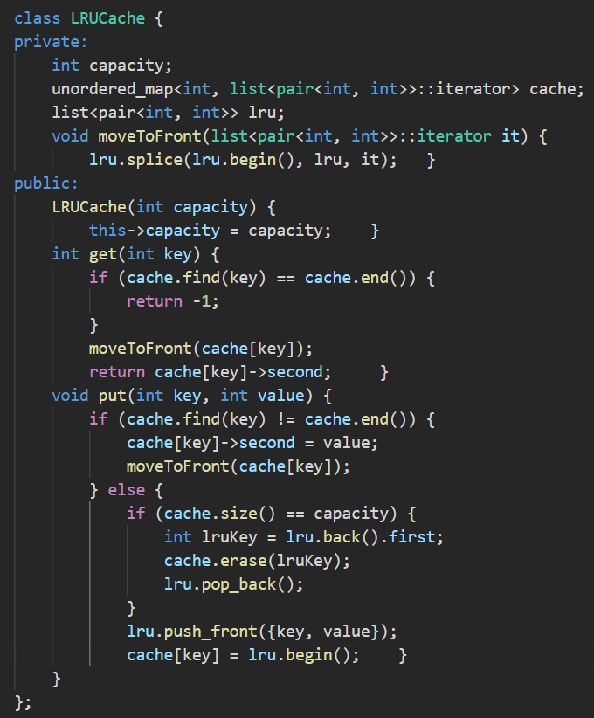

**Output:**

